Electromagnetic Energy
Each day your senses are flooded with sights and sounds transmitted by another type of energy—electromagnetic energy. This energy allows sound to travel on radio waves, lets you listen to and watch television, and enables you to see your world in an array of colors. This same energy also heats your food in a microwave and provides X-ray images of your bones or teeth. In this lesson, you will explore electromagnetic energy and some of its properties and applications in everyday life.



What Are Electromagnetic Waves?
When was the last time you saw a beam of light or a rainbow or felt the warmth of the sun on your skin? Have you ever wondered how a radio transmits sound or how an X-ray machine makes images of your teeth or bones? All of these experiences share a common aspect—the transfer of energy in the form of an electromagnetic wave . Next, you will explore the properties of electromagnetic waves and how they compare to other types of waves.

Gallery: Electromagnetic Waves

young woman putting sunscreen on her nose and cheeks

Electromagnetic waves transmit the energy of the sun, light, and color, and X-rays.



rainbow over a mountain and lake

Electromagnetic waves transmit the energy of the sun, light, and color, and X-rays.

female doctor and man looking at dental x-rays

Electromagnetic waves transmit the energy of the sun, light, and color, and X-rays.

Mechanical vs. Electromagnetic Waves
When you play a drum, the sound carries mechanical energy from the drum to your ears. When a light shines from a lighthouse, the light carries energy from the bulb in the lighthouse to the surrounding area. Sound and light both travel in waves, but sound travels as mechanical waves, while light travels as electromagnetic waves. Both types of waves transfer energy. In what other ways are these waves similar? They both exhibit the following properties:
• amplitude (the height of the wave)
• wavelength (the length of the wave)
• frequency (the number of waves per second)
What is one main way that mechanical waves and electromagnetic waves are different?
Light in space can transmit and reach Earth, but sound cannot transmit in a void. Mechanical waves cannot be transmitted without a medium.

Video: Electromagnetic Spectrum

The electromagnetic spectrum consists of high frequency gamma rays and x-rays at one end. At lower frequencies, there are ultraviolet visible light and infrared waves. At still low frequencies, there are microwaves and radio waves. All these waves travel at the speed of light and can be described by their wavelength, or frequency. Frequency is measured in hertz. One hertz is one wave per second. Two hertz is two waves per second. Four hertz is four waves per second. A million waves per second is called a megahertz. Wavelength and frequency are related. As the waves get shorter, the frequency increases. If the frequency is doubled, the wavelength is halved.

Wave Differences
Mechanical waves can only transfer energy through a substance called a medium. The waves cause particles in a medium to move and transmit energy between them. If you strike a bell, you will hear it ring because air serves as a medium to carry sound waves. In space, you will not hear the bell ring because there is no medium to carry the sound waves. Electromagnetic waves do not require a medium to transfer energy because their transfer is due to electric and magnetic fields. Electromagnetic waves transfer energy in empty space called a vacuum . Light from the Sun easily travels to Earth through the vacuum in space.

Animation: Bell Sound, Wave Differences

Animation of an astronaut ringing a bell here on earth in which you can hear the bell ringing.

Animation of an astronaut ringing a bell in space asking why can you not hear the sound of the bell ringing.

Speed Differences of Waves
Although electromagnetic waves do not require a medium to transfer energy and actually travel fastest through a vacuum, they can pass through matter, too. The speed of an electromagnetic wave slows as it travels through matter and as the density of matter increases. For example, a beam of sunlight travels faster through air than through a glass window. In this image, the molecules of matter slow the passage of electromagnetic waves.
On the other hand, mechanical waves require the movement of particles in matter to transfer energy. The speed they travel depends on matter density and how well it springs back when compressed or slightly displaced. For example, if you strike a block of wood and a steel beam with a hammer, sound will travel faster through the denser steel beam.
Would sound waves travel faster through air or through water? Sound waves travel faster through water than through air. This is because the molecules in a liquid are closer together than they are in a gas, such as air, and the molecules transfer vibrations from one molecule to another more quickly.

Animation: Speed Differences of Waves

A line with ends labeled A and B with four equally spaced hash marks, and squiggly line to the left of point A. Title says light passing through a vacuum. Picture below contains same line but has two blue balls between points A and B, and is titled light passing through a medium.

The Speed of Light
Imagine a dark, stormy night and a bright streak of lightning cutting across the sky. Moments later, the sound of thunder roars above your house. Why do you see the lightning before you hear the thunder? The answer lies in the speed of electromagnetic waves—the speed of light .
Electromagnetic waves travel fastest through a vacuum, but just how fast do they travel? They travel at a speed of 300,000 km/s (186,000 mi/s)—the speed of light. Nothing else in the universe travels as fast! In fact, electromagnetic waves of light travel thousands of times faster than mechanical waves of sound in the same medium. This is why you often see lightning in the sky before you hear the thunder clap.

Animation: Lightning

Thunderstorm across the sky

During a thunderstorm, you often see lightning in the sky before you hear the thunder clap.

Electromagnetic Spectrum
Electromagnetic waves transmit energy as radiant energy . Frequency of an electromagnetic wave determines how much radiant energy is carried. The range of electromagnetic waves is called the electromagnetic spectrum . The illustration of the spectrum shows how electromagnetic waves are arranged from low to high frequencies.
How does frequency relate to wavelength? Longer wavelengths result in smaller, lower frequencies. Shorter wavelengths result in larger, higher frequencies.

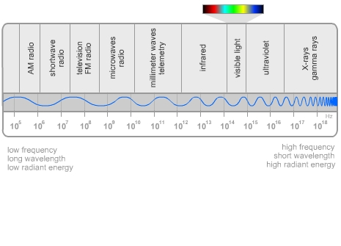

Radio and microwaves are at one end of the electromagnetic spectrum. These waves have a low frequency and long wavelength, carrying the least radiant energy on the electromagnetic spectrum. Radio waves broadcast from radio stations encode information for sounds. Microwaves transfer energy to heat food in a microwave oven.
X-rays and gamma rays are at the other end of the electromagnetic spectrum. They have a high frequency and short wavelength, carrying the most radiant energy on the electromagnetic spectrum. X-rays can penetrate the skin to make images of bones. The middle section of the spectrum includes infrared, visible light , and ultraviolet waves.

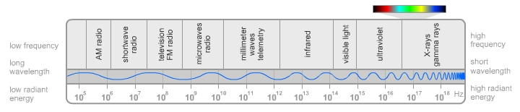

Light from the Sun
The Sun is Earth's major source of light. Its radiant energy is transmitted to Earth in electromagnetic waves of various wavelengths. The wavelengths of light from the Sun mainly fall into categories of infrared light, visible light, and ultraviolet light.
Infrared (IR) means "below red," and these light waves have a lower frequency and longer wavelength than visible light. Infrared light warms the Earth. Ultraviolet (UV) means "beyond violet," and these light rays have a higher frequency and shorter wavelength than visible light. Ultraviolet waves, or UV rays, carry more energy than infrared or visible light and can cause sunburn and skin damage.
How are IR and UV lights used in everyday life? IR light can be used to keep food warm under warming lamps for fast-food restaurants. UV light is sometimes used by hospitals to kill bacteria and sterilize equipment.


Visible Light
The small part of the electromagnetic spectrum that human eyes can detect, visible light, is divided into seven ranges of wavelengths. Your eyes perceive these different wavelengths as colors.
The colors making up visible light are red, orange, yellow, green, blue, indigo, and violet. In the next lesson, you will explore more about visible light and learn how light waves travel, interact, and are perceived by the human eye.

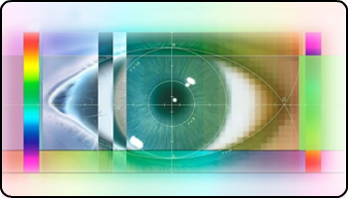

Human eyes can only detect the visible light wavelengths on the electromagnetic spectrum. We perceive those different wavelengths as colors.

More about Electromagnetic Waves
Did you ever wonder exactly what electromagnetic waves are, how they are produced, or exactly how they travel through the universe?
Electromagnetic waves are actually transverse waves made of both electric fields and magnetic fields . Both electric and magnetic fields are found in regions in space. The electromagnetic waves are produced when electric charges vibrate or accelerate.
The relationship between electricity and magnetism creates electromagnetic waves, causing them to travel. If there are changes in the electric field, the magnetic field also changes and vice versa. The result is an electromagnetic wave that can travel through empty space, a vacuum, or any type of matter.
How do electromagnetic waves compare to sound waves? Electromagnetic waves are transverse waves with the two fields running perpendicular to the direction in which the wave travels. Sound waves are longitudinal waves, where the displacement runs parallel to the direction in which the wave travels.

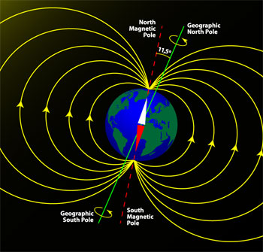

Assignment: Waves Concept Map Exploration
Your concept map will compare the manner in which energy is transferred by mechanical waves and electromagnetic waves. Include the following somewhere in your concept map:
- types of energy transferred
- medium required (if applicable) for transfer of energy
- speed of energy transfer through various medium (solid, liquid, gas)
Use the concept idea bank to help you. You may want to include additional vocabulary and ideas, too.

